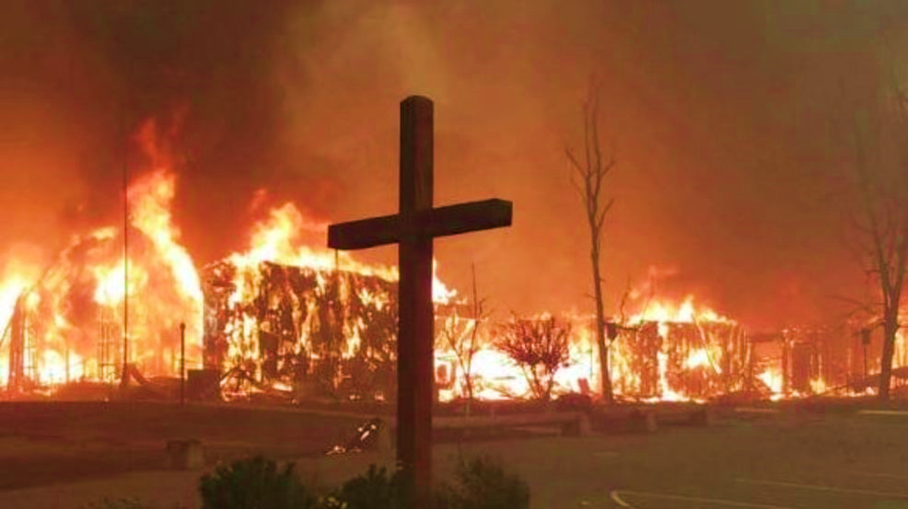

**The 2020 Bushfire Tragedy**

**Ecumenical Prayer**

Catholic Diocese of Sale, Victoria.

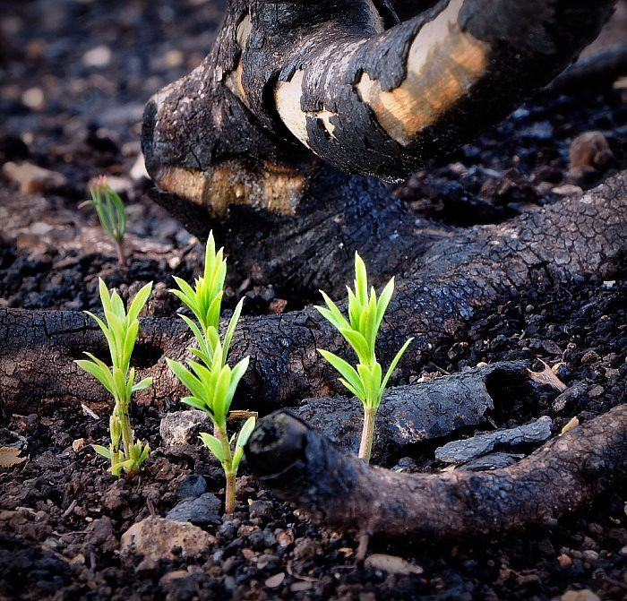

*Our time of prayer together is focused where our hearts and minds have beckoned over the last weeks and more…*

*Individuals who have died*

*People who are missing*

*Those traumatised by the fires*

*Families whose homes have been destroyed*

*People forced to flee their properties*

*Those who have lost their livelihood*

*The death of farm animals and livestock*

*The destruction of habitat and wildlife*

*Those who try to hold the advance of the flames*

*Those who do what they can to help*

*The shift from crisis to recovery*

*The need to care for our good earth*

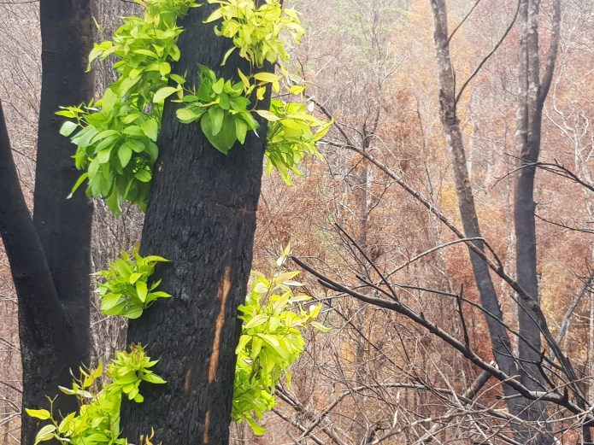

**Welcome**

All are welcomed here tonight as we join together to pray to the Lord for comfort, consolation, strength and forbearance.

**Call to Prayer**

Leader: All our shock, all our disbelief

**All: We cry to you, O Lord.**

Leader: All our terror, all our fear

**All: We cry to you, O Lord.**

Leader: All our pain, all our loss

**All: We cry to you, O Lord.**

Leader: All our grief, all our tears

**All: We cry to you, O Lord.**

Leader: For the desolation of the earth

**All: We cry to you, O Lord.**

Leader: For the plight of your creatures

**All: We cry to you, O Lord.**

Leader: Those who have died.

**All: We cry to you, O Lord.**

Leader: Those who are missing

**All: We cry to you, O Lord.**

Leader: God of our hearts,

We are heavy with sadness at the tragedy that has befallen so many…

we struggle to comprehend the scope of the destruction and horror of recent times…

Our hearts are like stones in our chests as we mourn the dead and stand in solidarity with the survivors.

Lord, where is the joy, peace and hope that you promise?

Have you forgotten us, Lord?

**The Silence**

In the quiet, place your own needs for consolation before the Lord and the intentions of all those who are suffering due to the fires.

***Hymn Be Not Afraid [1]***

**Lighting of the Christ Candle**

*A single candle is lit as a sign of the risen Jesus present here amongst us.*

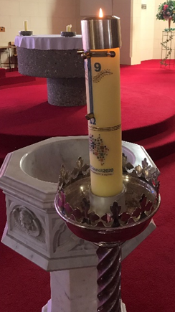**Opening Responses**

Come among us, God of our hearts:

You, who hollowed out the valleys

and swept the mountains skyward

**All: Come God, and meet us here**

Come among us, God of our hearts:

You, who crafted the meandering rivers

and spread the dapple of the forest floor.

**All: Come God, and meet us here**

Come among us, God of our hearts:

You, who etched the verdant coastline

and inlaid a crust of golden sands.

**All: Come God, and meet us here**

Come among us, God of our hearts:

You, who fashioned the shy lyrebird

and the koala high among the gums.

**All: Come God, and meet us here**

Come among us, God of our hearts:

You, who stands beside us at the brink

and graces us with strength and hope.

**All: Come God, and meet us here.**

Come among us, God of our hearts:

You, who groans with us in our sorrow

and weeps with us in our grief.

**All: Come God, and meet us here**

Come among us, God of our hearts:

You, who lures us out of isolation

and into the warmth of community.

**All: Come God, and meet us here**

Come among us, God of our hearts:

You, who calls us ever onwards

with the sweet balm of your promise.

**All: Come God, and meet us here**

Come among us, God of our hearts:

You, who dance in the eerie silence

and shine through the darkest night.

**All: Come God, and meet us here**

The Lord, your God, is in your midst,

the Mighty to save.

He will take great delight in you;

He will renew you in his love.

He will rejoice over you with singing. (Zephaniah 3:17)

**All: Amen**

**Psalm of Response Psalm 34 [2]**

**God’s Word For Us Today** Matthew 11:25-30  (NRSV)

At that time Jesus said, “I thank you, Father, Lord of heaven and earth, because you have hidden these things from the wise and the intelligent and have revealed them to infants; yes, Father, for such was your gracious will.All things have been handed over to me by my Father; and no one knows the Son except the Father, and no one knows the Father except the Son and anyone to whom the Son chooses to reveal him.

“Come to me, all you that are weary and are carrying heavy burdens, and I will give you rest. Take my yoke upon you, and learn from me; for I am gentle and humble in heart, and you will find rest for your souls. For my yoke is easy, and my burden is light.”

The Gospel of the Lord

**All: Praise to you, Lord Jesus Christ**

**Reflection on the Gospel**

*Some years ago a large extended family had a great reunion. On a beautiful sunny day, the children and their families gathered around their aged mother for a family photograph. It was such a big event in the rural community that a reporter from the local paper was present when the group photo was taken and he had the audacity to ask the mother, “Who was your favourite?” I can still remember being shocked by the question and I seem to recall that all the children visibly leaned in to hear their mother’s answer. Her response came straight from her heart: “The one who was sick!”*

*Is this not our own heart response to the tragedy of the bushfires? Our compassion spills over for the victims and we find ourselves standing in solidarity with the needs of the vulnerable in the depths of their pain. Just as Jesus was moved with compassion for the suffering and deep need of those whom he encountered we, too, at this time, ask with Him of the blind man Bartimaeus, “What do you want me to do for you?”*

*Each of us can make a difference by responding from our capacity to the ‘cry of the poor’ at this time and into the future: financial generosity, giving of our time and goods, tender prayers for ourselves and others, and a greater awareness of our environmental footfall.*

**Ritual Action**

During the singing of the Taizé chants you are invited to come forward and place a sprig of rosemary at the foot of the cross, confident in the transformative and redemptive power of the cross at work in our lives at this time.

**Chants: O Lord Hear My Prayer [3]**

**Prayers of Intercession** *Sung response*

Leader: As we gather to remember the dead, the injured, the homeless and the trauma, let us ask God to gentle the lives of all those who struggle with grief and loss.

Reader 1: For all who have died in the bushfires, that they may rest now, safe in the loving arms of God. Lord, hear us.

**All: Lord, let your mercy be on us, as we place our trust in you. [4]**

Reader 2: For all who grieve for their loved ones, that God will wipe away their tears and give them consolation and peace. Lord, hear us.

**All: Lord, let your mercy be on us, as we place our trust in you.**

Reader 3: For the wounded and the bereft, who are suffering, that God will comfort them and heal them in body and spirit. Lord, hear us.

**All: Lord, let your mercy be on us, as we place our trust in you.**

Reader 4: For all those who so courageously fought the bushfires, that they may, always and everywhere, be protected and kept safe from harm. Lord, hear us.

**All: Lord, let your mercy be on us, as we place our trust in you.**

Reader 5: For all those who worked to rescue the injured, tending the dead and taking care of the survivors, that God bless them in their daily life. Lord, hear us.

**All: Lord, let your mercy be on us, as we place our trust in you.**

Reader 6: For our Gippsland communities who have been ravaged by the bushfires, that they may be supported and helped by the concern and the practical care that we can offer them. Lord, hear us.

**All: Lord, let your mercy be on us, as we place our trust in you.**

Reader 7: For our state Victoria and our nation, that God grant us compassion, wisdom and discernment as we respond to this tragedy. Lord, hear us.

**All: Lord, let your mercy be on us, as we place our trust in you.**

Reader 8: For the plants and animals of God’s Creation: that we may continue the work of the Creator by protecting and nurturing the natural world that mirrors the face of the Holy One. Lord, hear us.

**All: Lord, let your mercy be on us, as we place our trust in you**

Leader: This is the time to vocalise any particular prayer intention. Perhaps for someone close to you… something that weighs heavily on your heart… some aspect overlooked….. Lord, hear us.

**All: Lord, let your mercy be on us, as we place our trust in you.**

Leader: Consoling God, source of all comfort, lift the burden of despair and grief from those who suffer. Fill us with the hope of your Spirit. Show us how you want us to live and give us the courage and the goodness to reach out to others in their distress. Do not abandon your people in their time of need. We ask you this in the name of the One who knew suffering and loss, Jesus Christ our Lord and brother.

**All: Amen**

**The Lord’s Prayer**

Leader: In unison and with hands joined in solidarity let us pray with confidence to the Father in the words Jesus gave us.

**All: Our Father, who art in heaven, hallowed be thy name. Thy kingdom come; Thy will be done on earth, as it is in heaven. Give us this day our daily bread. And forgive us our trespasses, as we forgive those who trespass against us, and lead us not into temptation, but deliver us from evil. For the kingdom, the power and the glory are yours, now and for ever, Amen.**

**Sign of Peace**

Leader: Lord, Jesus Christ, you said to your apostles: I leave you peace, my peace I give to you. Look not on our sins, but on the faith of your people, and grant us the peace and unity of your kingdom where you live for ever and ever.

**All: Amen**

Leader: The peace of the Lord be with you always

**All: And also with you**

Leader: Let us offer each other a sign of the Lord’s peace at this troubling time.

**Prayer for All Present**

God of our hearts,

we stumble the road from devastation and loss

in the presence of both deep sorrow and stoic resilience.

Courage and grace abound,

Capacity and strength swell,

Commitment and solidarity reassure.

May we strive together to create a future

ripe with hope and plump with possibilities.

Be with us as a new path opens before us:

Increase our commitment,

Strengthen our resolve,

Anchor our solidarity,

Forge our resilience.

We ask this through him who knows the sorrows and joys of what it is to be human, Jesus, your Son, our Lord and brother.

**All: Amen**

**Hymn: The Lord is My Shepherd [5]**

[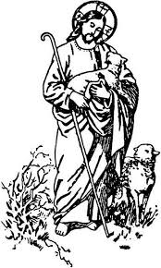](http://www.google.com.au/url?sa=i&rct=j&q=&esrc=s&source=images&cd=&cad=rja&uact=8&ved=0CAcQjRw&url=http://presentationschool.net/description-of-catechesis-of-the-good-shepherd&ei=OHMPVfrhL8jW8gXxpIKIBQ&psig=AFQjCNE1l_8Y2V2uS6WQzDWN32jYzA8G8w&ust=1427161865328096)

**Unison Prayer**

Leader: We pray together ….

All: May I go this night blessed by all things:

gentleness of breath, delight of eyes,

wonder of voice, intimacy of touch,

warmth of the other, eternity of soul,

essence of the journey together,

joy of a shared earth,

embrace of God.

May I live my days…

strong of mind, compassionate of heart,

gentle in word, gracious in awareness,

courageous in thought, generous in love,

determined in action, fierce in justice,

strong in desire, thoughtful of others,

at one with the all things…

through the One who draws us

together in the Home of Belonging.

**Benediction**

*Community leaders are invited to give the blessing*

Leader: Bow your head and ask for God’s blessing.

We give you thanks, Gentle One,

You, who have touched our souls.

You have loved us from the moment

of our first awakening and have held us

in joy and in grief.

Stay with us, we pray.

Leader/s:

May the Lord grace you with his presence

and with it, the fullness of your own humanity.

May you claim your strength and need,

your awesome and fragile beauty...

that, encouraged by His presence, you might work

to restore hope and health to those in need

and renew the face of Gippsland and beyond.

May Almighty God bless you all…

the Father, Son and Holy Spirit. **†**

**All: Amen**

**Hymn Be With Me, Lord [6]**

*Thank you all for being present. Please join us for a light supper.*

*Ecumenical Liturgy: Compiled and adapted by Michael Hansen, with original texts by Michael Hansen, 2020, and prayers from the 2009 and 2010 Bushfire Ecumenical Rituals prepared and written by Michael Hansen, Lavalla Catholic College Traralgon and Sophy Morley, Diocesan Coordinator for Liturgy and Pastoral Ministry, Catholic Diocese of Sale.*

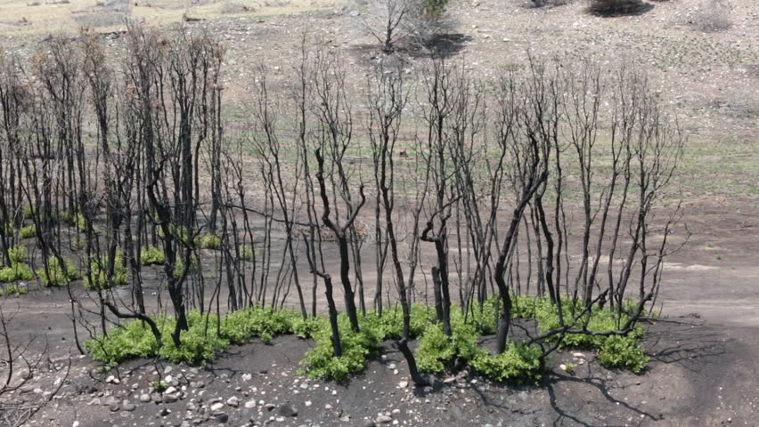

1. **Be Not Afraid.**  Text and Music: © 1975, 1978, Robert J. Dufford SJ, and OCP Publications, Portland OR, USA.
2. **Psalm 34**. Text: Ps 34 : 2-3, 6-7, 18-19,23. John Foley SJ, alt. Music: John Foley SJ. © 1978, 1991, John B Foley SJ & OCP Publications, Portland OR, USA.
3. **O Lord, Hear My Prayer.** Text: Ps 102, Taizé Community. Music: Jacques Berthier.

   © 1982, Ateliers et Presses de Taizé.
4. **A Trusting Psalm.** Text: Ps 33, Kevin Bates sm. Music: Kevin Bates sm. © !985, Kevin Bates sm. One License, Catholic Diocese of Sale A-640527.
5. **The Lord is My Shepherd.** Text & Music: Brian Boniwell © Spectrum Publications, 1978.
6. **Be With Me Lord**. Text: Ps 91, Sarah Hart & Curtis Stephan. Music: Sarah Hart and Curtis Stephan ©2004 Sarah Hart & Curtis Stephan, Published by spiritandsong.com, a division of OCP Publications, Portland OR, USA. 