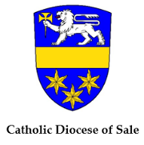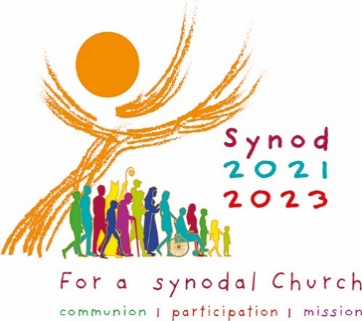**SYNOD JOURNEY 2021-2023**

**Advent 2021**

***Let’s Walk Together!***

During Advent we will be focussing on the first of the Synod Themes: **Communion**

This Mass resource has been prepared for your use for the Sundays of Advent:

* Bulletin notice
* Introductory Mass Commentary
* Prayers for the Advent Wreath
* Prayers of Intercession
* Delve Deeper into the Bible
* Quote of the Day (Pope Francis on Synodality)
* PowerPoint Slides for each Sunday in Advent (separate file) using a weekly question from the **Communion** section of the Synod Questions – a good time to display these is in the time after Communion, inviting some quiet reflection.
* The Advent and Synod themes have been woven together in this Mass kit so that the Advent theme in selected Scripture of the day and the message of the Synod (Communion) may be transmitted to your assemblies during the liturgy and at gatherings.

**To underline Communion, key messages to transmit include:**

* “We are spread out across our entire diocese but God unites us as one.”
* “The aim is not for all of us to be the same, but to walk forward together, sharing a common path and embracing our diversity.”
* “The communion that God builds in our midst is stronger than any divisions.”
* “Amidst our many differences, we are united in our common baptism, as members of the Body of Christ.”

To manifest Communion at the various levels of the local Church, **parishes, movements, and different communities from across the diocese can be highlighted**.

**SYNOD JOURNEY 2021-2023**

**First Sunday of Advent, Year C**

**28 November 2021**

***Hope***

**Bulletin notice**

**SYNOD 2021 -2023 *Let’s Walk Together!***

Companions on the Journey.** Jesus wants us to walk together side by side. Of those in our Church, who do we walk with and who is forgotten? What about those outside the Church, who is not included or welcomed? Have your say <https://tinyurl.com/HavingASay> or use the QR code

Introductory video, prayers and resources at <https://www.cdsale.org.au/synod-of-bishops>

**Mass Commentary**

Today the Church begins a new liturgical year with the beginning of Advent – a time of waiting hope and expectation as we journey together looking forward to the birth of Christ. During this time, we are invited to think of ourselves as a synodal church, as companions on the journey of life. As we celebrate this season of Advent, we think again of the love of God for us, endless as ever new, as symbolised in our Advent Wreath, which will be blessed today. We hear St Paul’s encouragement to us today and throughout Advent: “***May the Lord make you increase and abound in love for one another and for all.”***

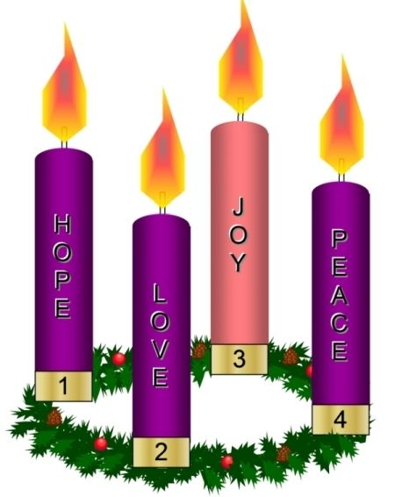**Blessing of the Advent Wreath** *(from the Book of Blessings)*

Lord our God, we praise you for your Son, Jesus Christ:

he is Emmanuel, the hope of the peoples,

he is the wisdom that teaches and guides us,

he is the Saviour of every nation.

Lord God, let your blessing come upon us

as we light the candles of this wreath.

May the wreath and its light

be a sign of Christ's promise to bring us salvation.

May he come quickly and not delay.

We ask this through Christ our Lord. Amen

*First Candle is lit by a parishioner*

Finish the blessing by singing *Come, Lord Jesus* <https://tinyurl.com/AdventWreathSong>

**Prayers of the Faithful**

Presider As we begin this season of Advent, we await the coming of Christ with hope and joyful expectation.

We pray for church communities in every place, that they be a leaven of Advent hope and peace amid the anxieties of the world. In hope we pray:

**Come, Lord Jesus.**

For the world and for a global revolution of justice: that the needs of nations most disadvantaged by climate change and the COVID pandemic be met by the world community. In hope we pray:

**Come, Lord Jesus.**

For ourselves and all the members of the Church throughout the world: that this Synodal Process may lead us ever deeper into the **communion** of the Church, foster our **participation** in it, and equip us to go out on **mission** to spread the Good News of the Gospel. In hope we pray:

**Come, Lord Jesus.**

For the Church. That as disciples of Christ, we may journey as companions, walking with one another on the same road. In hope we pray:

**Come, Lord Jesus.**

For a spirituality of journeying together: that we may be formed as disciples of Christ,

as families, as communities, and as human beings, through our experience of this Synodal

journey. In hope we pray:

**Come, Lord Jesus.**

For those affected by conflict, hunger, disease and alienation: that God’s grace may touch hearts burdened by the cares of life. In hope we pray:

**Come, Lord Jesus.**

Presider Lord God, you show us that our redemption is near at hand. Hear our prayers, and help us to be watchful, ready for the glorious coming of our Saviour Jesus Christ. We ask this through Christ our Lord.

**Amen.**

**Solemn Blessing** *(optional)*

May the almighty and merciful God,

by whose grace you have placed your faith

in the First Coming of his Only Begotten Son

and yearn for his coming again

sanctify you by the radiance of Christ’s Advent

and enrich you with his blessing.

**Amen**.

As you run the race of this present life,

may he make you firm in faith,

joyful in hope and active in charity.

**Amen**.

So that, rejoicing now with devotion

at the Redeemer’s coming in the flesh,

you may be endowed with the rich reward of eternal life

when he comes again in majesty.

**Amen**.

And may the blessing of almighty God,

the Father, and the Son, ✠ and the Holy Spirit,

come down on you and remain with you for ever.

**Amen**.

**Delve Deeper into the Bible**

Each week of Advent has a traditional theme. A series of short videos offered by the Bible Project explores the ancient words Shalom (peace), Yakhal (hope), Chara (joy) and Agape (Love) which reveal the deeper meanings of these words. Learning the fuller meanings of these words can enrich our Advent journey.

Head to <https://bibleproject.com/advent-word-series-churches/> or use QR Code



**Quote of the Day (Pope Francis on Synodality)**

The Christian community must reflect the "style of God, who travels the paths of history and shares in the life of humanity." This is a "time to look others in the eye and listen to what they have to say, to build rapport, to be sensitive to the questions of our sisters and brothers."

(Pope Francis, Homily for the Launch of the Synod 2021-2023, 10 October 2021)

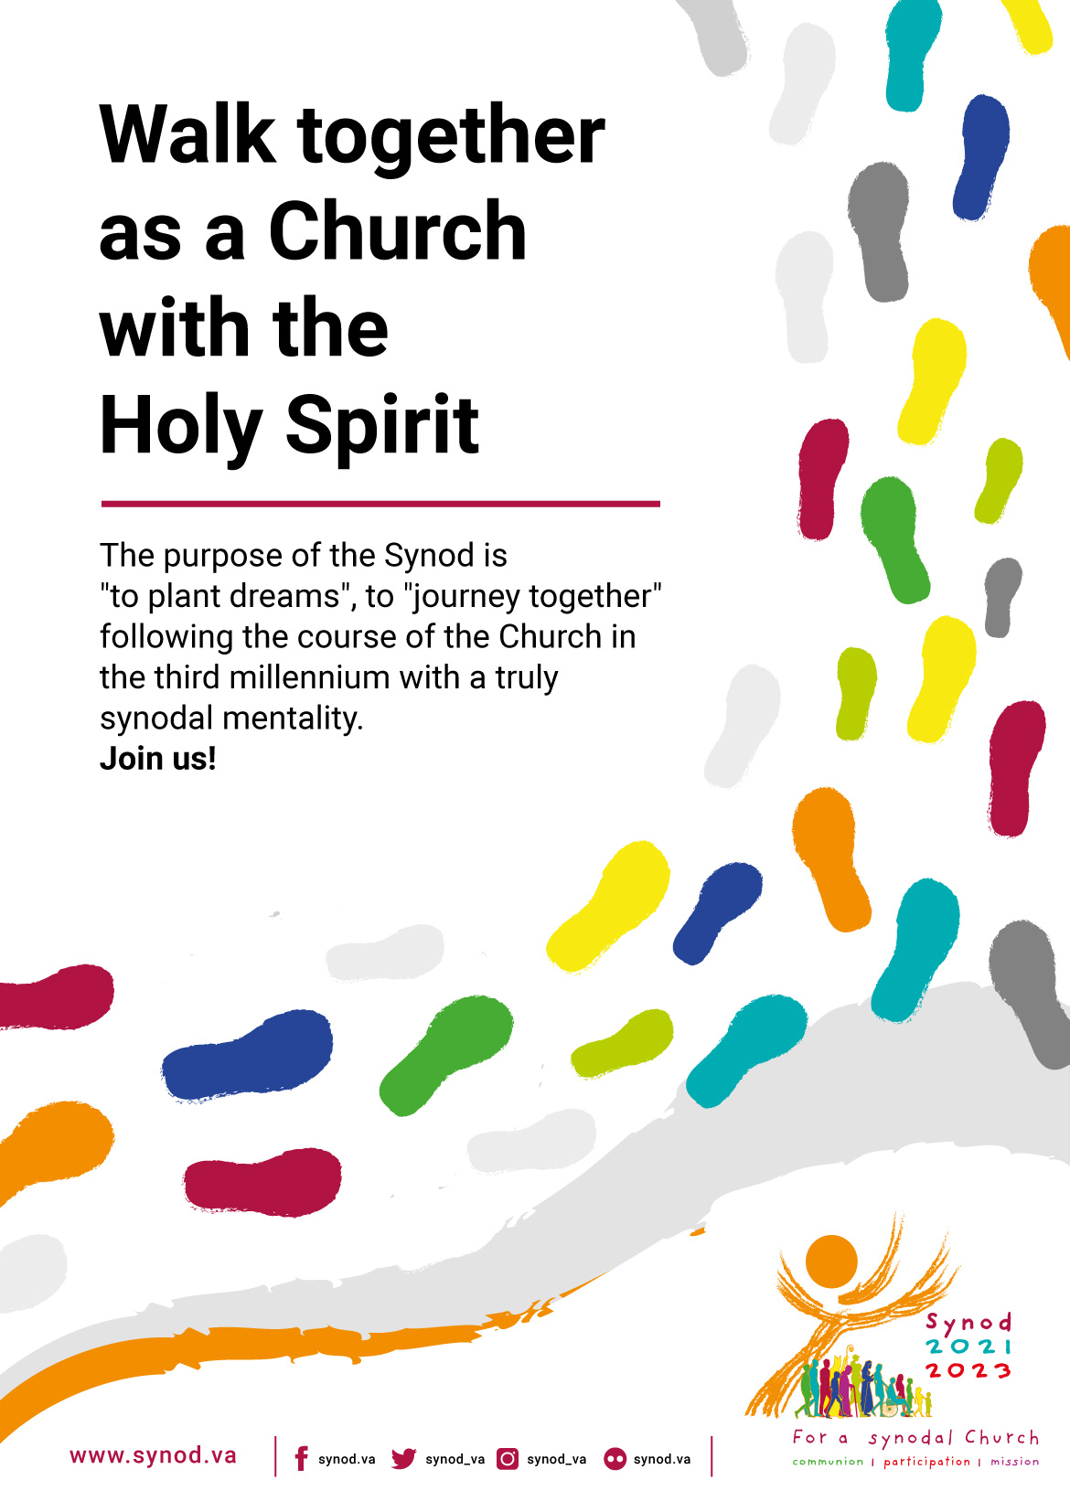

**SYNOD JOURNEY 2021-2023**

**Second Sunday of Advent, Year C**

**5 December 2021**

***Faith***

**Bulletin notice**

**SYNOD 2021 -2023 *Let’s Walk Together!***

**Our Listening.** Listening with an open heart and mind is the first step. How good are we Catholics at listening with the ear of our hearts? Who don’t we listen to? Have your say <https://tinyurl.com/HavingASay> or use the QR code

Introductory video, prayers and resources at <https://www.cdsale.org.au/synod-of-bishops>

**Mass Commentary**

Today, on the Second Sunday of Advent, we gather with faith and in expectation of the3 coming of Jesus Christ, whose arrival was heralded by John the Baptist. May we be attentive and listen for God’s voice of comfort and reassurance through this time of waiting. As journey with each other, trying to become a more synodal church, we are urged to listen with the ears of our hearts to God and to one other, to become ever more deeply a Church of caring and closeness.

**Lighting the Candles of the Advent Wreath**

Today, as we gather on the Second Sunday of Advent, we light the second of the candles, remembering how God’s love was manifested to the People of Israel through the law and the prophets. This week we hear how the word of God came to John son of Zechariah, in the wilderness. The prophetic cry of John the Baptist echoes the call of Isaiah, the call of repentance and the invitation to turn our lives towards God.

*Second Candle is lit by a parishioner*

Sing *Come, Lord Jesus* <https://tinyurl.com/AdventWreathSong>

**Prayers of the Faithful**

Presider The Lord Jesus is always near to us, always coming into our hearts. As we wait for the Lord’s coming, we ask our heavenly Father to hear our prayers.

For Pope Francis and all who lead the People of God: that by their example of walking side by side with their communities, the Church may be transformed into living more deeply the mission of Christ. In faith we pray:

**Come, Lord Jesus**

We pray for our parish community, that our celebration of Advent will confirm us in holiness and make us more generous in love. In faith we pray:

**Come, Lord Jesus**

For a listening ears and a generous heart: that as a synodal church walking with each other, our hearts and minds be open to listening to others without prejudice.

In faith we pray:

**Come, Lord Jesus**

We pray for all people living with disabilities, that their gifts will enrich the community and call us to a deeper embrace of our shared humanity. In faith we pray:

**Come, Lord Jesus**

Presider Lord God, your promise of salvation is close at hand. Hear our prayers, and help us to be like John the Baptist, by eagerly embracing your will for our world in Jesus Christ. We ask this through Christ our Lord.

**Amen**.

**Delve Deeper into the Bible**

Each week of Advent has a traditional theme. A series of short videos offered by the Bible Project explores the ancient words Shalom (peace), Yakhal (hope), Chara (joy) and Agape (Love) which reveal the deeper meanings of these words. Learning the fuller meanings of these words can enrich our Advent journey.

Head to <https://bibleproject.com/advent-word-series-churches/> or use QR Code



**Quote of the Day (Pope Francis on Synodality)**

**"Let us ask: in the church, are we good at listening? How good is the hearing of our heart? Do we allow people to express themselves, to walk in faith even though they have had difficulties in life, and to be part of the life of the community without being hindered, rejected or judged? Let us not soundproof our hearts."**

(Pope Francis, Homily for the Launch of the Synod 2021-2023, 10 October 2021)

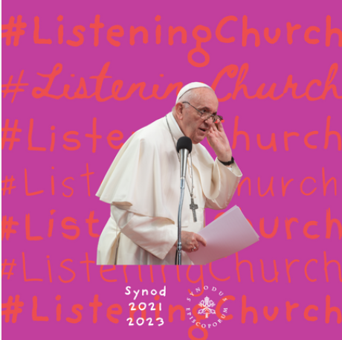

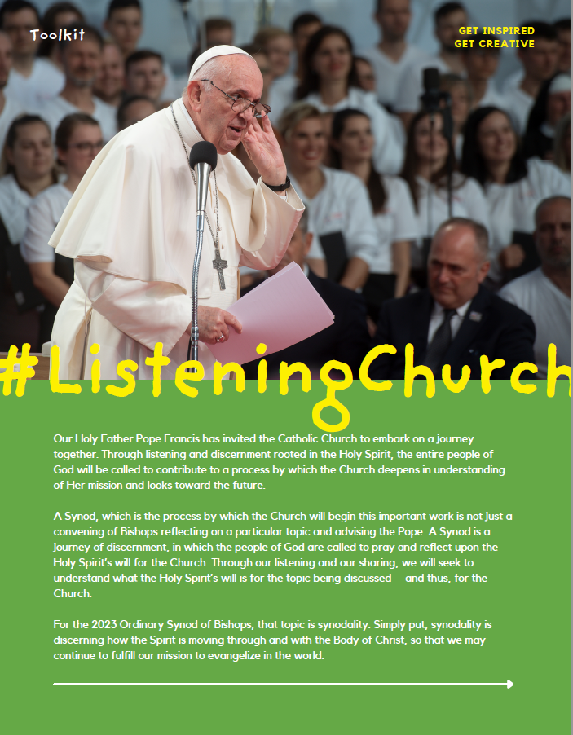

**SYNOD JOURNEY 2021-2023**

**Third Sunday of Advent, Year C**

**12 December 2021**

***Joy***

**Bulletin notice**

**SYNOD 2021 -2023 *Let’s Walk Together!***

Our Speaking Out:** Everyone is invited to speak boldly and courageously in truth and love. Are we as Catholics good at saying publicly what is important to us? If not, why not? Have your say <https://tinyurl.com/HavingASay> or use the QR code

Introductory video, prayers and resources at <https://www.cdsale.org.au/synod-of-bishops>

**Mass Commentary**

Today, the third Sunday of Advent marks the halfway point of our waiting for the birth of Christ. Today is also known Gaudete Sunday – *Gaudete* means rejoice and we will hear several times in our readings and psalm for today’s Mass. **“Cry out with joy and gladness: for the Holy One is near!”**

**Lighting the Candles of the Advent Wreath**

Today as we gather on the Third Sunday of Advent, we light the third candle, filled with joy and expectation at the coming of Christ, but who is already with us now. We also remember the ministry and witness of John the Baptist who summons us to heed the coming of the Holy One. May we also have the courage to voice God’s message of hope and truth.

*Third Candle is lit by a parishioner*

Sing *Come, Lord Jesus* <https://tinyurl.com/AdventWreathSong>

**Prayers of the Faithful**

Presider Advent is a time of waiting for Christ, united in the joy of the Gospel. With confidence, we call upon the Father to listen to our prayers.

That this Advent will be, for the Church, a faith filled journey toward deeper union with

Christ and through Christ, with each other.

In joyful hope, we pray

**Come, Lord Jesus**

For the Church: that she may bring good news to the poor, healing to the broken hearted and liberty to captives.

In joyful hope, we pray

**Come, Lord Jesus**

For a Church that celebrates: that our synodal journey together in the coming months will be based on listening together to the Word of God and the celebration of the Eucharist.

In joyful hope, we pray

**Come, Lord Jesus**

For the renewal of our Catholic parishes, schools and institutions around the world, that we

may proclaim the Kingdom of God by living out the joy of the Gospel.

In joyful hope, we pray

**Come, Lord Jesus**

That in this time of active vigilance, we will show special concern for the poor, the sick, the grieving and those in great need.

In joyful hope, we pray

**Come, Lord Jesus**

For the grace, in this coming week, to be free of anxiety and to be generous in showing

kindness.

In joyful hope, we pray

**Come, Lord Jesus**

Presider Lord God, the coming of your Son is near. Hear our prayers, and guide us in faith as we wait in joyful hope. We ask this through Christ our Lord.

**Delve Deeper into the Bible**

Each week of Advent has a traditional theme. A series of short videos offered by the Bible Project explores the ancient words Shalom (peace), Yakhal (hope), Chara (joy) and Agape (Love) which reveal the deeper meanings of these words. Learning the fuller meanings of these words can enrich our Advent journey.

Head to <https://bibleproject.com/advent-word-series-churches/>

or use QR Code

**Quote of the Day (Pope Francis on Synodality)**

### The "art of encounter," said Francis, is marked by listening and seeking to understand the other. "Every encounter, as we know, calls for openness, courage and a willingness to let ourselves be challenged by the presence and the stories of others."

(Pope Francis, Homily for the Launch of the Synod 2021-2023, 10 October 2021)

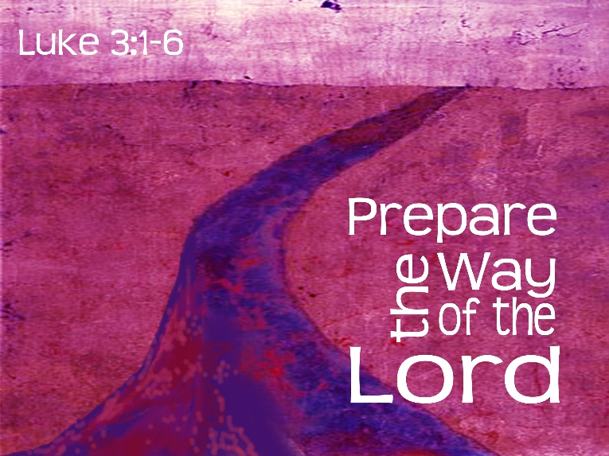

**SYNOD JOURNEY 2021-2023**

**Fourth Sunday of Advent, Year C**

**19 December 2021**

***Peace***

**Bulletin notice**

**SYNOD 2021 -2023 *Let’s Walk Together!***

Our Celebration:** Communal celebrations where we explore God’s Word and break bread are our glue. Are our celebrations guiding and inspiring our decisions & our lives and where are they failing? Have your say <https://tinyurl.com/HavingASay> or use the QR code

Introductory video, prayers and resources at <https://www.cdsale.org.au/synod-of-bishops>

**Mass Commentary**

Today on the Fourth Sunday of Advent, we hear of the beautiful meeting of Mary and Elizabeth, two courageous women who, despite their lowly status, were important in God’s plan for humankind. Mary’s generous and trusting ‘Yes’ to God opened the way to the incarnation of the Holy One among us. Blessed is she who believed that what was spoken to her by the Lord would be fulfilled. (Lk 1:45)

**Lighting the Candles of the Advent Wreath**

Today as we gather on the Fourth Sunday of Advent, we light the fourth candle representing peace, and the hope that the Prince of Peace mend divisions, heal our hearts and unite us as one human family. We remember how God’s love was manifested to the world through the generosity and courage of Mary.

*Fourth Candle is lit by a parishioner*

Sing *Come, Lord Jesus* <https://tinyurl.com/AdventWreathSong>

**Prayers of the Faithful**

Presider With longing for the Lord, our Emmanuel, and his coming at Christmas, we place our prayers before our loving God.

That the season of Advent will be an occasion for a deeper personal encounter with Jesus Christ, the prince of light and peace.

In peace, we pray

**Come, Lord Jesus**

For the Church as she journeys towards the Synod 2021-2023: that our walking together as authentic companions in Christ will bear fruit in new ways of being at the service of one another.

In peace, we pray

**Come, Lord Jesus**

For our governments and community leaders: that they be inspired to lead through their committed service, be advocates for truth and justice and show compassion and understanding, especially for the most vulnerable members of our society.

In peace, we pray

**Come, Lord Jesus**

For the unity of Christians: that dialogue between Christians of different denominations,

united by one Baptism, may radiate with new brightness on this Synodal journey.

In peace, we pray

**Come, Lord Jesus**

For an increase in vocations to the priesthood and consecrated life; that young men and women may generously respond to the invitation of Jesus.

In peace, we pray

**Come, Lord Jesus**

Presider Loving Father, during this holy season of Advent, keep us watchful and alert. Fill our hearts with expectation so that, through the hope and tenderness of Christmas, we may shake off our indifference and be filled with your light. Through Christ our Lord.

**Amen**.

**Delve Deeper into the Bible**

Each week of Advent has a traditional theme. A series of short videos offered by the Bible Project explores the ancient words Shalom (peace), Yakhal (hope), Chara (joy) and Agape (Love) which reveal the deeper meanings of these words. Learning the fuller meanings of these words can enrich our Advent journey.

Head to <https://bibleproject.com/advent-word-series-churches/>

or use QR Code

**Quote of the Day (Pope Francis on Synodality)**

"There is no need to create another church, but to create a different church. Keep us from becoming a 'museum church,' beautiful but mute, with much past and little future."

"May we be pilgrims in love with the Gospel and open to the surprises of the Spirit."

(Pope Francis, Homily for the Launch of the Synod 2021-2023, 10 October 2021)

**Celebrating Christmas – The Church must find its way back to Jesus.**

By Fr Bryan Massingale in US Catholic

<https://uscatholic.org/articles/202111/the-church-must-find-its-way-back-to-jesus/>

“The mystery of Christmas is that God—the Incomprehensible Infinite Reality—does the unthinkable: God becomes a human being, with all our vulnerabilities and limitations. Christmas celebrates God’s love becoming human for us.

In a Jesus like us who bleeds, hungers, and dies, we see someone who spent his whole life centred on making the God who loved him real to others. His whole life focused on making God’s love visible and tangible for us—so that we in turn would spend our lives loving and living as he did. Christmas is about the mystery of love: God’s love for Jesus; Jesus’ love for us; and our love for one another, especially the hungry, thirsty, homeless, and imprisoned.

Christmas calls the church to refocus on its core mission: to lead people to a life-changing encounter with the love of God through Jesus. This is the key to the church’s conversion and credibility. That would be a Christmas gift to celebrate.”

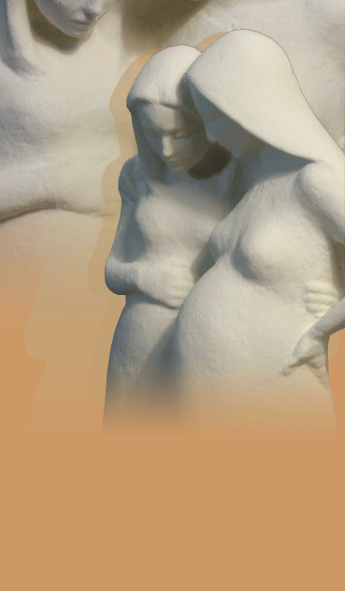



**Be mothers of God…**

We are all meant to be mothers of God.

What good is it to me if this eternal birth of the divine Son

takes place unceasingly,

but does not take place within myself?

And, what good is it to me if Mary is full of grace

if I am not also full of grace?

What good is it to me for the Creator to give birth to his Son

if I do not also give birth to him in my time and my culture?

This, then, is the fullness of time: when the Son of Man is begotten in **us**.

*Meister Eckhart (1260-1328)*

***The Incarnation***

*If you want, the Virgin will come walking down the road,*

*pregnant with the holy, and say,*

*“I need shelter for the night,*

*please take me inside your heart, my time is so close.”*

*Then, under the roof of your soul,*

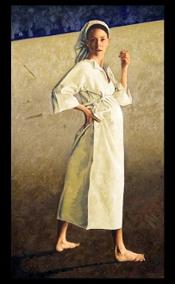*you will witness the sublime intimacy,*

*the divine, the Christ, taking birth forever,*

*as she grasps your hand for help,*

*for each of us is the midwife of God,*

*each of us.*

*Yes, there, under the dome of your being*

*does creation come into existence eternally,*

*through your womb, dear pilgrim*

*– the sacred womb of your soul,*

*as God grasps our arms for help:*

*for each of us is his beloved servant,*

*never far.*

*If you want, the Virgin will come*

*walking down the street,*

*pregnant with Light and sing.*

The Visitation, by Frank Mesaric

St John of the Cross

*Love Poems from God: Twelve Sacred Voices from the East and West.*

*Translation by David Ladinsky. Penguin Compass.*

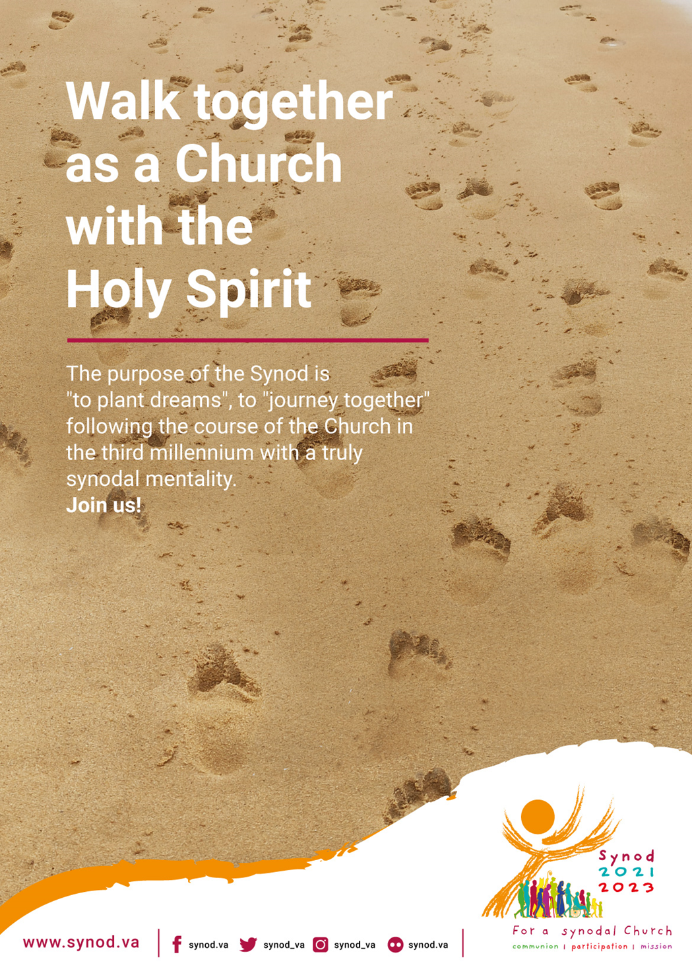

**Copyright Acknowledgements**

Prayers of the Faithful: prayer texts were composed or otherwise adapted from a variety of sources including

* Synod of Bishops: Liturgical Suggestions for the Opening of the Synod in Australia <https://www.catholic.org.au/synodalchurch>
* Creative Ministry Resources (Liturgy Help) <https://www.liturgyhelp.com/>
* Australian Catholics Prayers of the People <https://www.australiancatholics.com.au/edition/prayers-of-the-people>
* Magnificat <https://uk.magnificat.net/home>